Multiple-choice section – choose the correct answer

Question 1 [10.3]

Which pair of events is mutually exclusive?

A Choosing an even number or choosing a multiple of 5, both from the numbers 1 to 100.

B Drawing an Ace or a King from a normal pack of 52 playing cards.

C People who like beans and people who like broccoli.

D Students who play hockey and those who play basketball.

Question 2 [10.5]

A four-sided spinner, labelled 1−4, is spun three times. The probability that the third spin results in a 4, given that both the previous two spins were 4s, is:

**A**  **B**  **C**  **D** 

Question 3 [10.1]

A lucky dip has 7 movie tickets, 7 music download cards, 8 of both prizes and 3 booby prizes. The probability of randomly choosing movie tickets is:

A  B  C  D 

Question 4 [10.2]

In a group of 10 people, 7 like movie A and 8 like movie B. If all like at least one movie, what is the probability that a person chosen at random likes both movies?

A  B  C  D 

Question 5 [10.5]

I draw 2 cards from a normal pack of 52 playing cards without replacement. What is the probability that the second card is an ace if I know the first card is a not an ace?

**A**  **B**  **C**  **D** 

Question 6 [10.3]

A card is drawn at from a standard pack of 52. The probability of obtaining a Queen or a heart is:

A  B  C  D 

Question 7 [10.3]

Two dice are rolled and the sum of the numbers is even. The probability that exactly one of the dice shows 4 is:

A  B  C  D 

Question 8 [10.4]

A biased coin has Pr(H) = 0.6.  
If the coin is tossed twice, the probability of obtaining tails exactly once is:

A 0.6 B 0.4 C 0.48 D 0.64

Multiple-choice results: ___ / 8

Short answer section

Question 9 2 marks [10.2]

Choose from the following words and expressions to complete the sentences below.

complementary events dependent events independent events sample space  
tree diagram two-way diagram Venn diagram

(a) The two events ‘a number greater than 4’ and ‘a number less than or equal to 4’ are ____________________________.

(b) The list of all possible outcomes is called the ___________________.

Question 10 1 mark [10.4]

Explain in a sentence what you understand by the phrase ‘A and B are independent events’.

Question 11 4 marks [10.2]

Students were surveyed as to whether they played tennis or squash. The probability that a student plays tennis only was 0.2, squash only was 0.5 and playing both was 0.1.

(a) Complete the following table to show this information.

|  |  |  |  |
| --- | --- | --- | --- |
|  | tennis | not tennis |  |
| squash |  |  |  |
| not squash |  |  |  |
|  |  |  |  |

(b) Find the probability that a person chosen at random does not play:

(i) either sport (ii) squash

Question 12 9 marks [10.1]

Two bags each hold four T-shirts: a red, a green, a black and an orange. A T-shirt is selected at random from each bag.

(a) Represent the sample space on a tree diagram.

(b) Find the probability of selecting T-shirts that are:

(i) both red

(ii) same colour

(iii) a red and a black

(iv) different colours.

Question 13 8 marks [10.3]

Cards numbered from 1 to 30 are shuffled then a single card is drawn. Find:

**(a)** Pr(multiple of 2 or 5)

**(b)** Pr(factor of 10 of 12)

**(c)** Pr(even or a factor of 24)

**(d)** Pr(neither a multiple of 2 nor a multiple of 5)

Question 14 5 marks [10.4]

A coin is biased so that the chance of heads is three times that of tails. The coin is tossed three times.

(a) Show the outcomes using a tree diagram and write the probabilities along the branches.

(b) Find the probability of tossing:

(i) three heads in a row

(ii) two tails and one heads in that order

(iii) two tails and one heads in any order.

Question 15 5 marks [10.6]

A bag contains eight Minties and twelve Caramels. Two lollies are selected, one after the other,  
with no replacement.

**(a)** Draw a tree diagram labelled with probabilities to illustrate this information.

**(b)** Calculate the probability that the lollies are both Minties.

**(c**) Calculate the probability that the lollies are different.

Question 16 4 marks [10.5, 10.6]

Of the 80 members in a karate club, 32 are students and of these, 8 have black belts. There are  
20 members in total with black belts.

(a) Show the information in a table.

(b) Find the probability that a member chosen at random:

(i) is a student with a black belt

(i) is not a student and does not have a black belt

Question 17 6 marks [10.2, 10.5]

In a Year 10 class of 30 students, 25 are right-handed, 18 walk to school and 16 of the walkers are right-handed.

(a) Show this information in a Venn diagram.

(b) Find the probability that a student chosen at random:

(i) is left-handed and walks to school

(ii) is left-handed, given that the student walks to school

(iii) walks to school, given that the student is left-handed.

Question 18 6 marks [10.2]

I have a coin, a normal six-sided die and a spinner numbered 1 to 8. Find the number of outcomes in the sample space in the following situations. In each case, the order of the outcome does not matter. For example, H1 is the same outcome as 1H.

**(a)** Toss the coin and roll the die.

**(b)** Use the spinner and the coin.

**(c)** Use the spinner and the die.

**(d)** Use all three.

Question 19 4 marks [10.6]

Cooper plays basketball. When the game starts, the probability that he will get a 3-pointer in is  
 but once he scores one, his probability of getting the next one in is .   
If Cooper has two shots at 3-pointers, what is the probability that he gets:

**(a)** the second one in if he misses the first one

**(b)** both shots in?

Question 20 6 marks [10.3]

A normal six-sided die is rolled twice.

**(a)** Show the sample space in a grid.

**(b)** Find the probability that:

**(i)** both results are the same **(ii)** the two numbers add to 4

**(iii)** the two numbers add to 4 or 5 **(iv)** there is at least one 2.

Question 21 4 marks [10.6]

Julia has found that on her way to work she has to go through three sets of traffic lights. The probability that the first set of lights is green is 0.6, the second set is 0.4 and the last set is 0.3. Calculate the following probabilities.

**(a)** On any particular morning all the lights are green.

**(b)** All the lights are red.

**(c)** Two sets of lights are green and the other is red.

Question 22 3 marks [10.6]

A bag contains 10 balls, 3 of which are red, 2 are green and the rest blue. A ball is chosen at random, its colour noted and then another ball is chosen without replacing the first ball. Find the probability that the balls chosen are:

(a)both red

(b) red then blue, in that order

(c) red and blue in any order.

(b) Now find the probability that a blue is chosen for neither ball.

Question 23 3 marks [10.6]

A couple is trying to decide on a name for their new baby girl. They like the names Lily, Taylor, Rose and Grace. They plan to pick names out of a hat but they can’t decide on whether to give her one name or two.

(a) How many different outcomes are possible for one name and for two names?

(b) What is the probability that the baby will be named Taylor Grace, if the selection is made randomly from all possible outcomes?

Short answer results: ___ / 70

Extended answer section

Question 24 10 marks [10.2, 10.5]

An organisation employs 80 people. There are 50 people with specialist training in word processing, 41 trained for reception, 40 for MYOB, 29 with training in word processing and MYOB, 24 trained for word processing and reception, 21 trained for MYOB and reception and 11 with extra certificates in all three areas. The remainder are involved in administration.

(a) Complete the following Venn diagram to show this information.

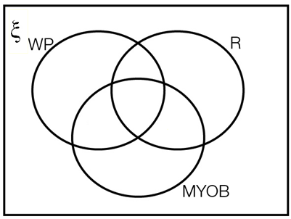

(b) Where on the Venn diagram are the employees involved in administration?

(c) If a person is selected at random, find the probability that the person is involved with:

(i) administration

(ii) at least two of the skills of word processing, MYOB and reception

(iii) no more than one of the skills of word processing, MYOB and reception

(iv) exactly one of the skills of word processing, MYOB and reception.

(d) If a person has MYOB skills, what is the probability they have word processing skills?

Question 25 7 marks [10.5]

A company has two machines that make armchairs.

* 95% of armchairs produced by Machine A are acceptable.
* 90% of armchairs produced by Machine B are acceptable.
* Machine A produces 40% of the armchairs manufactured at the factory.

(a) Complete the tree diagram to show this information. (In the diagram, G stands for acceptable and G' stands for not acceptable.)

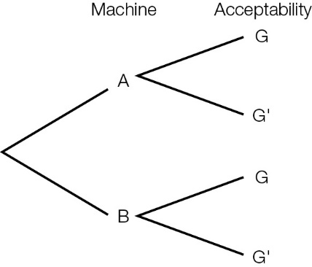

(b) (i) What is the probability that a randomly chosen armchair is an acceptable armchair manufactured by Machine A?

(ii) What is the probability that a randomly chosen armchair is an unacceptable armchair manufactured by Machine B?

(c) An armchair chosen at random is not acceptable. Find the probability that it was produced by Machine A. Give your answer as a fraction in simplest form.

Extended answer results: ___ / 17

TOTAL test results: ___ / 95